Changes to https://preview.rosevillenewchurch.com.au/

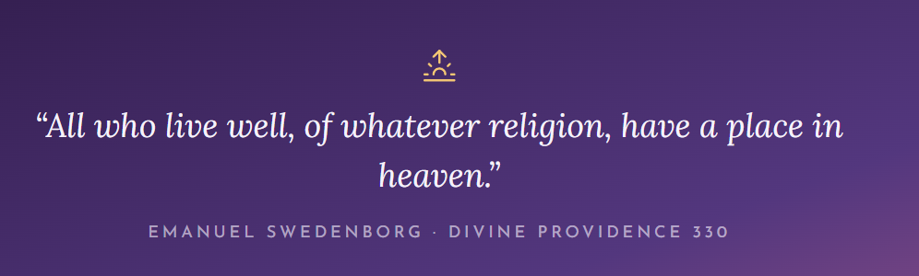
Leave out
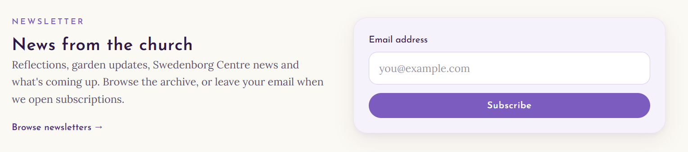

On the Home page

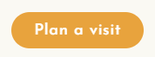
Leave out

On the menu.

